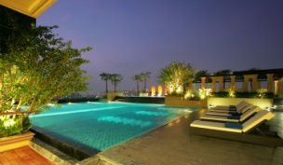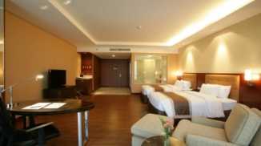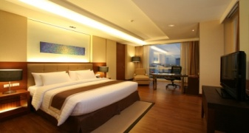

Reservation Form

THE GRAND FOURWINGS CONVENTION HOTEL

**AAOM 2025**

**June 18 - 21, 2025**

**Bangkok, Thailand**

**Last Name : First Name:**

**Address :**

**Address :**

**City :**

**Fax:**

**Expiry Date :**

**Date of Issue :**

**Flight/Time of Arrival :**

**Flight/Time of Departure:**

**Country :**

**Telephone :**

**Passport No. :**

**Place of Issue :**

**Arrival Date :**

**Departure Date :**

**Deluxe (40 SQ.M.) …………………Single THB 2,600 net include breakfast**

**Deluxe (40 SQ.M.) …………………Twin or Double THB 2,600 net include breakfast**

**Grand Deluxe (59 SQ.M.) …………………Single THB 3,400 net include breakfast**

**Grand Deluxe (59 SQ.M.) …………………Single orTwin or Double THB 3,400 net include breakfast**

**Deluxe Suite (84 SQ.M.) …………………Twin or Double THB 4,900 net include breakfast**

**Grand Suite (94 SQ.M.) …………………Twin or Double THB 6,400 net include breakfast**

The above special rates are subject to room availability and valid for reservations made on or before **Friday,16th  May 2025**; after which rooms and room rates will be subject to availability at time of reservation.

All rates are inclusive of 10% service charge & thereafter 7% goods and service tax (GST)

**For make reservation**

Please contact Reservation Department at Tel: +662 378-8000 Ext.4104-5 Fax 0-2378-8000 or

E-mail: [reservation@grandfourwings.com](mailto:reservation@grandfourwings.com) ,reservation03@grandfourwings.com, [savichaya_s@grandfourwings.com](mailto:savichaya_s@grandfourwings.com) ,

[reservation01@grandfourwings.com](mailto:reservation01@grandfourwings.com) ,reservation02@grandfourwings.com, [reservation04@grandfourwings.com](mailto:reservation04@grandfourwings.com)

* A Credit Card number provided, just for guarantee booking only. Can be a company or guest’s credit card and payment method can be changed upon arrival.
* Accommodation payment will settle upon arrival to prior hotel.
* Guest may cancel reservation by notify the hotel 15 days before the arrival date. If cancellation is not notified or no show, the hotel will deduct one night room charge from guest’s credit card.
* Please be informed that the hotel Check-in time is at 14:00 hrs, and Check-out is at 12:00 (noon).
* Early Check-in or Check-out requirement will be subject to availability upon arrival.

Should you require any further information, please do not hesitate to contact us directly.

……………………… …………………………….....

**Guest Signature Reservation Department**